|  |
| --- |
| College LaSalle |
| Project - Oriented Object Programming User and Technical Manual |
|  |
| Presented to: Mihai Maftei. |

|  |
| --- |
| Meet Hingu  11/8/2024  Version 1.0 |

1. **Start by adding a short description of your project, and the languages (technologies) used:**

This first section of the project is about lottery and generating random numbers and display them.

1. Language: C#
2. Used tool(s): VS2022 Windows Form (.Net Framework), MS Word, AI (ChatGPT)
3. **Present the print screens of yours forms and have a detailed description of the functionalities (step by step).**

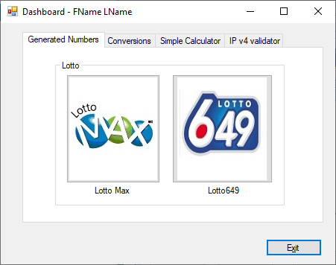

1. If you click on tab LottoMax

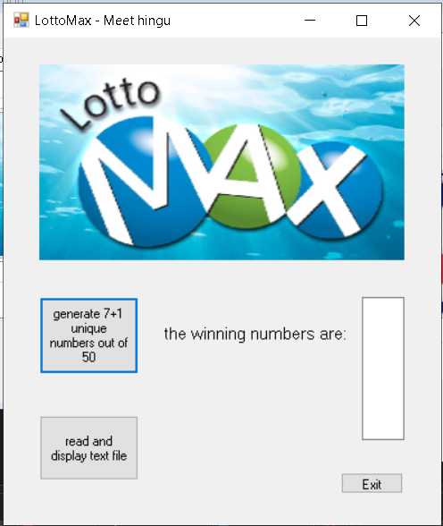

1. If you click on tab Lotto649

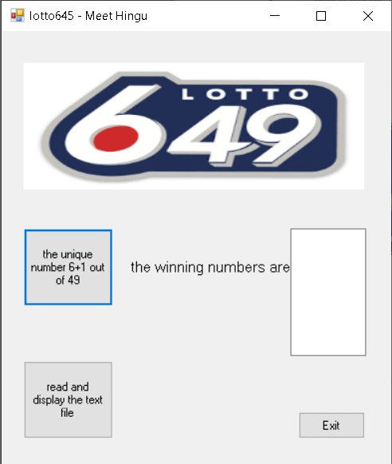

1. **Present the code of your application (forms).**

**Dashboard**

… your code goes here

LotoMAX

using System;

using System.Collections.Generic;

using System.ComponentModel;

using System.Data;

using System.Drawing;

using System.Linq;

using System.Text;

using System.Threading.Tasks;

using System.Windows.Forms;

namespace MainProjectSection1

{

public partial class lottoMax : Form

{

public lottoMax()

{

InitializeComponent();

}

private void pictureBox1_Click(object sender, EventArgs e)

{

}

private void button1_Click(object sender, EventArgs e)

{

Random random = new Random();

string randomNumbers = "";

for (int i = 0; i < 8; i++)

{

int randomNumber = random.Next(1, 50);

randomNumbers += randomNumber.ToString() + Environment.NewLine;

}

textBox1.Text = randomNumbers.Trim();

}

private void button2_Click(object sender, EventArgs e)

{

this.Close();

}

}

}

… your code goes here

Loto649

using System;

using System.Collections.Generic;

using System.ComponentModel;

using System.Data;

using System.Drawing;

using System.Linq;

using System.Text;

using System.Threading.Tasks;

using System.Windows.Forms;

namespace MainProjectSection1

{

public partial class lotto645 : Form

{

public lotto645()

{

InitializeComponent();

}

private void label1_Click(object sender, EventArgs e)

{

}

private void button1_Click(object sender, EventArgs e)

{

Random random = new Random();

string randomNumbers = "";

for (int i = 0; i < 7; i++)

{

int randomNumber = random.Next(1, 49);

randomNumbers += randomNumber.ToString() + Environment.NewLine;

}

textBox1.Text = randomNumbers.Trim();

}

private void button3_Click(object sender, EventArgs e)

{

this.Close();

}

}

}

… your code goes here

Money Conversion

… your code goes here

IPv4 & IP

… your code goes here

Calculator

… your code goes here

1. **Present the classes and/or methods that you create or you did use in the project and the class diagram(s) and the algorithm of the method(s) .**

|  |  |
| --- | --- |
| **Class/Method Name** | **Description** |
| 1. Class Calc | Enter a short description of the class or of the method ………………. |
| 1. Method for Calc class |  |
|  |  |
| 1. Class IP | Enter a short description of the class or of the method ……………….. |
| 1. void Method(int total) | Enter a short description of the class or of the method ……….. |
|  |  |
| 1. Constructor() | Enter a short description of the class or of the method ………… |
|  |  |

**Class diagram:**

**Method(s) algorithm:**

1. **Present the difficulties that you have, what was the hardest and the easiest part of your project application development.**

2014-10-30 8:30 – Can’t open the form by clicking the button.

8:45 Solved: Asking somebody…

… your presentation goes here …